# Introduction

* 1. Overview

Lighting systems within smart home environments have rapidly evolved, influenced significantly by the integration of Internet of Things (IoT) technologies, which enhance both user experience and energy efficiency. Studies by prominent researchers (Byun et al., 2013; Kar & Kar, 2014) have shown that modern lighting systems can greatly improve user interactivity and environmental adaptability. However, despite these advancements, many systems do not fully utilize the potential for environmental responsiveness or user-centric design, often leading to suboptimal user experience (Minker, n.d.). This project introduces "Lumiverse Strip," an innovative LED matrix system utilizing WS2812 LED strips arranged in a unique wave-like pattern, designed to address these shortcomings. The system integrates multiple functionalities including. Designed to address these shortcomings. The system integrates multiple functionalities including. Deployed within a smart home environment, this project aims to utilize a combination of sensors and user input to dynamically adjust lighting conditions, enhancing both comfort and user interaction. The system's information transmission is mainly through MQTT, and no data is stored, so there is no need to worry about personal information.

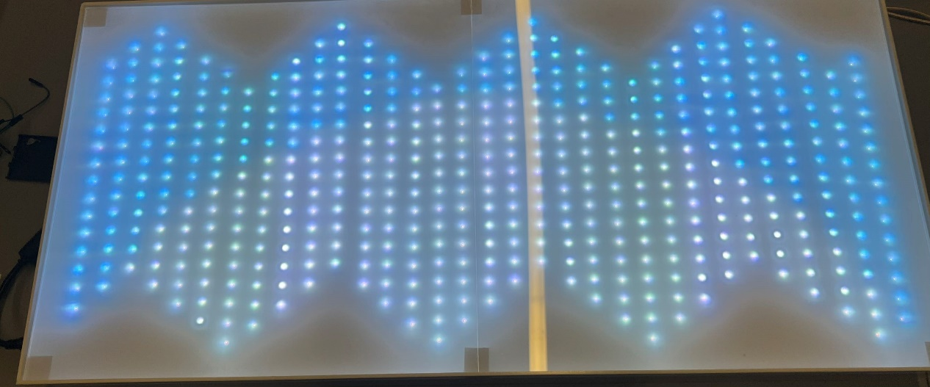

*Figure 1.1 Lumiverse Strip*

* 1. Aims

The objective of this project is to develop a versatile and intelligent LED lighting system that caters to various user needs and environmental conditions.

Recent studies underscore the importance of intelligent lighting systems in modern environments, emphasizing their role in energy efficiency and user interaction (Minker, n.d.; De Paz et al., 2016). This project aims to push the boundaries of what is possible with LED lighting, offering a highly customizable and interactive solution that sets a new standard for intelligent lighting systems.

The key functions include:

* **Voice Control**: Allow the LED matrix to change functions based on human voice.
* **Environment Monitoring:** Accurately display real-time environmental data, including temperature, humidity, atmospheric pressure, IAQ, and heat index.
* **Music Ambience Lighting**: Synchronize the LED patterns with music to create a dynamic and immersive experience.
* **Weather Simulation**: Display weather conditions visually through the LED patterns, providing real-time environmental feedback.
* **Motion Detection**: Use Passive Infrared (PIR) sensors to detect human movement and display corresponding patterns, enhancing interaction.
* **Gesture and App-Controlled Text Display**: Allow the matrix to show text messages based on hand gestures or commands received from a mobile app.
* **Circadian Rhythm Lighting**: Adjust lighting patterns and colours to mimic sunrise and sunset to align with human circadian rhythms, promoting improved sleep and overall well-being.
  1. Research Question and Hypothesis

With the aforementioned aims as the basis, the research question and hypothesis is as follows:

***How can a smart light strip that integrates music atmosphere lighting, environmental information collection, and gesture recognition capabilities be designed to enhance users' perception, interaction, and communication, thereby improving their quality of life? The ability to convey specific information through remote gestures will further promote emotional exchanges and barrier-free communication among users.***

* 1. Structure

To address the aforementioned research question and hypothesis, this paper will offer critical reviews of the related work in each function (Chapter 2). Then, it will introduce the design and implementation of "Lumiverse Strip"

All code and documentation are provided

on GitHub (<https://github.com/Hazzd12/dissertation_2024>).

# Literature Review

* 1. Overview

Intelligent LED lighting systems, as crucial components of modern smart homes and urban illumination, have garnered widespread attention due to their energy-saving, efficient, and multifunctional attributes. Not only do they enhance users' quality of life, but they also contribute to environmental protection through energy conservation and emission reduction. This article provides an overview of recent advancements in key functionalities and implementation technologies of intelligent LED lighting systems, encompassing voice control, music ambience lighting, environment monitoring, weather simulation, PIR sensor triggering, gesture and app-controlled text display, and circadian rhythm lighting. By analysing existing research, it delves into the current technological status.

* 1. Related work

Recent studies, such as those by Rashidov et al. (2024) have demonstrated the possibility of sound-responsive LED systems to build a unique and personalised atmosphere, representing the promising trend in innovative, interactive, and adaptive commercial lighting solutions. They also have shown that music synchronization in LED lighting can significantly enhance the ambience of a space. The integration of weather simulation and environmental data visualisation, as explored by Pauzi, Hasan (2020) and Petrariu (2016), provides real-time environmental feedback, while motion detection technologies (Alvarez et al., 2018) enable interactive displays based on human movement.

1. Voice Control

Voice control systems are becoming increasingly popular in smart homes. Tonmoy et al. (2019) designed the application of voice control by developing a 16x16 LED matrix display device for children's alphabet learning. This study demonstrates the possibility of combining voice control with other control methods, thereby expanding the application scenarios of smart lighting systems.

Lin et al. (2019) further expanded an intelligent voice-controlled desk lamp controller, employing non-specific speech recognition technology to control LED lights. This system, based on the LD3320 voice chip, accurately recognises user voice commands and controls the lights on/off switch and brightness. Researches indicate that voice control systems significantly enhance user convenience and smart home experience.

This approach is fantastic by integrating voice-controlled or interactive features that utilize the LED display, to broaden appeal and functionality.

1. Environment Monitoring

Environmental monitoring in smart homes plays a crucial role in enhancing living conditions through technological advancements. The integration of advanced sensors enables a comprehensive understanding of indoor environments. The research (Petrariu et al, 2016) investigated the innovative applications of LED field sensors in real-time 3D near-field visualization, presenting a novel approach to environmental sensing.

Their study illustrates that LED sensors can serve dual functions: emitting light and providing spatial and environmental data. This approach offers a compact and efficient solution for the continuous monitoring of environmental parameters within a space, coupled with dynamic 3D visualization of these parameters.

1. Music Ambience Lighting

Music ambience lighting creates a specific atmosphere by synchronising light changes with music. Guo et al. (2019) proposed an intelligent control system based on RGB-LED lights for music rhythm. This system utilises image colour analysis and pulse width modulation (PWM) technology to enable lights to change along with the rhythm of the music, enhancing users' auditory and visual experiences. The research demonstrates the potential of music ambience lighting in enhancing entertainment effects and user satisfaction. The application prospects of music ambience lighting in scenarios like family gatherings and leisure entertainment are vast, further enhancing the multifunctionality and user experience of intelligent LED lighting systems. Future research could explore improving users' immersion experience through enhancing light effects and synchronisation techniques.

However, their use of the CIE1931 XYZ colour space, a standard from the early 20th century, presents limitations. This colour space, while historically significant, is less intuitive compared to more modern alternatives such as HSV (Hue, Saturation, Value). The HSV colour space offers a more straightforward method for evenly distributing colours, which is particularly beneficial in dynamic lighting applications.

Moreover, the study did not employ Fast Fourier Transform (FFT) algorithms for frequency analysis. FFT is pivotal for decomposing a musical piece into its constituent frequencies, allowing for a more detailed and reliable analysis of the music. By not utilizing FFT, the system's ability to accurately synchronize lighting with the complex elements of music, such as tempo and rhythm, is potentially compromised.

1. Weather simulation

The weather simulation feature of intelligent LED lighting systems involves replicating current external weather conditions through light. Hovorov et al. (2022) conducted research on pattern control in architectural and artistic lighting systems, proposing an intelligent control system based on mathematical models. This system can dynamically adjust the colour and brightness of the lights based on real-time weather data, thus simulating different weather effects such as sunny, cloudy, or rainy conditions. Such applications not only enhance users' living experiences but also hold significant potential in energy conservation.

To simulate weather effectively, incorporating real-time weather data feeds can be a good solution. By connecting with online meteorological services, the system can access up-to-date weather information, adjusting the lighting animation to mirror external conditions like sunlight, cloud cover, and thunderstorms, enhancing the user’s connection with the outside environment even from indoors.

1. Motion Detection

Passive Infrared (PIR) sensors enable smart LED lights to automatically adjust lighting based on human activity. Rajakumar et al. (2022) designed a room lighting automation system based on Arduino and PIR sensors. This system utilises PIR sensors to detect motion from a distance, and when someone passes by, it controls the lights to sequentially turn on and then off, serving as a reminder of the presence of individuals.

This system is particularly suitable for scenarios where people pass by but are not in the same space as the LED lights, enhancing spatial monitoring and security alertness. This technology is not only widely applied in home security but also plays a crucial role in public spaces such as office buildings, and parking lots, providing effective security reminders and management functions.

1. Gesture and App-Controlled Text Display

Gesture and App control are emerging features of intelligent LED lighting systems, enabling specific light displays by detecting user gestures or app commands. The alphabet learning device developed by Tonmoy et al. (2019) not only supports voice and infrared remote control but also gesture and app control, allowing users to control lighting and text display through simple gestures or a mobile app. Additionally, Hung et al. (2016) proposed a smartphone-based gesture recognition system that controls home sockets and LED arrays via wireless communication and Bluetooth technology. Research indicates that this gesture recognition system performs excellently in colour control and wireless communication, significantly enhancing the interactivity and user experience of smart home devices.

Gesture and App control not only enhance user-device interaction but also provide a touchless and remote-control method, catering to modern demands for hygiene and convenience. This technology has a wide range of applications, from home entertainment to educational displays, and from commercial advertising to information displays, all with significant development potential.

1. Circadian rhythm lighting

Circadian rhythm lighting aims to regulate users' biological clocks by simulating sunrise and sunset in natural light. It is friendly for people who live in environments where they cannot see the outside world and have a weaker sense of time perception. Tian (2021) proposed a creative design for human-centric home lighting, emphasising the impact of light on human psychological health. The study indicates that adjusting the brightness and colour temperature of the light can effectively improve users' work and rest states, promoting a healthy circadian rhythm.

Circadian rhythm lighting has significant effects on improving users' sleep quality and enhancing daytime alertness, particularly suitable for homes and workplaces, enhancing the health functions of smart lighting systems. Future research could further explore how to adjust light based on individual differences to achieve more precise circadian rhythm regulation effects and use smart algorithms to optimize light settings, thereby improving users' quality of life.

In summary, intelligent LED lighting systems demonstrate broad application prospects in areas such as voice control, music ambience lighting, weather simulation, PIR sensor triggering, gesture and app-controlled text display, and circadian rhythm lighting.

Despite significant progress in existing research, challenges remain in areas like system integration, user experience, and energy efficiency optimization. Future research should further explore multifunctional integrated smart lighting systems to meet diverse user needs and drive the development of smart homes. Additionally, interdisciplinary collaboration should be emphasized, combining advanced sensing technologies, artificial intelligence, and big data analysis to enhance the intelligence level and user experience of intelligent LED lighting systems.

# Methodology

1. Sensor and Actuator Choices

To achieve the above functions, the intelligent LED lighting system needs to select suitable sensors and actuators to ensure the reliability and user experience of the system. The following are the main sensors and actuators of this product:

**WS2812B (LED strip)**

|  |  |  |
| --- | --- | --- |
| LED type | Advantage | Disadvantage |
| Generic RGB LED Strips | Lower cost | No individual LED addressability; |
| APA102 | Higher data transmission | Higher cost; Additional clock wire |
| SK6812 | Additional colour mixing | Higher cost and power consumption |

*Table 1 Advantages and Disadvantages of other LED types compared to WS2812B*

As shown in Table 1, the WS2812B offers an impressive combination of individually addressable LEDs, energy efficiency, and cost-effectiveness. It can be controlled with a single data line, eliminating the need for additional wiring and simplifying integration with microcontrollers and IoT devices. Research (Nguyen-Ly et al., 2019; Tsao et al., 2021) indicates that WS2812B is an efficient and cost-effective LED light with a built-in driver chip, supporting multi-colour display and single-wire control. This makes WS2812B particularly suitable for smart lighting systems requiring complex lighting effects, such as music ambience lighting and weather simulation just like "Lumiverse Strip".

Consequently, the WS2812B was chosen as the ideal LED strip for implementing an advanced, customizable lighting solution in a smart home environment, while maintaining project affordability and system reliability.

**HC-SR501 PIR (motion detector)**

Studies (Masykuroh et al., 2021; Jiru, 2013) have employed the HC-SR501 PIR sensor, making it the preferred choice for smart lighting and security systems due to its high sensitivity and low cost. HC-SR501 features a long detection distance and stable performance, suitable for use in various environments. However, environmental temperature and obstacles may affect its detection effectiveness, hence future research needs to further optimize the sensor's sensitivity and anti-interference capability.

Compared to other motion detectors like E8-DNK which has a higher cost and smaller detection range, the advantage of HC-SR501 lies in its low cost, reliable motion detection capability and simple interface design, making it suitable for lighting systems requiring automatic sensing and control. It is suitable for use in " Motion Detection” functionality.

**MAX9814 (audio amplifier)**

|  |  |  |
| --- | --- | --- |
| Type | Advantage | Disadvantage |
| LM386 | Low cost | Low reliability in audio analysis |
| MP34DT01 | Built-in ADC; Detailed audio analysis | High cost; High complexity; Complicated integration |
| ADNP401 | Omnidirectional pickup; Flat frequency response | High cost; High complexity; Complicated integration |
| MAX9814 | Built-in ADC; Low-noise signal amplification; High-quality sound capture in environments; Low cost | Slightly more complexity than LM386 |

*Table 2 Comparison between MAX9814 and other audio amplifiers*

As shown in Table 2, the MAX9814 is chosen for the "Lumiverse Strip" primarily for its Automatic Gain Control (AGC), which ensures consistent audio levels in diverse environments. Its ease of integration also suits the technical demands of the project, balancing advanced functionality with straightforward. Also, the design of the non-contact electronic stethoscope utilizes the MAX9814 as the audio amplifier (Joshitha et al., 2022), with the stethoscope's functionality heavily reliant on high-quality audio capture. Their research demonstrates that the MAX9814 provides adequate clarity and reliability for audio capture.

These features, combined with its low-noise performance and low cost, make MAX9814 an ideal choice for "Music Ambience Lighting" functionality.

**DF2301QG (voice recognition module)**

DF2301QG is an efficient voice recognition module widely used in voice control systems. This module adopts a dual-microphone design, providing better noise resistance and longer recognition distance. It can still perform relatively accurately and reliably even in noisy environments. Equipped with both built-in speaker and external speaker interfaces, it can provide real-time voice feedback of recognition results. The module has strong compatibility, supporting both I2C and UART communication modes. Additionally, it is compatible with various 3.3V or 5V controllers such as micro: bit, Arduino (Arduino UNO, Arduino Leonardo, Arduino MEGA), Raspberry Pi, and FireBeetle series, making it versatile for different applications. Comparing self-trained models for recognition significantly reduces development time and DF2301QG also offers strong reliability in voice recognition.

**BME680 (environment sensor)**

The comprehensive sensing capabilities of the BME680 fully meet the requirements for an effective indoor air quality monitoring system (Jose et al.,2019). This sensor not only tracks physical parameters such as temperature, humidity, and pressure but also monitors chemical parameters like VOCs and other gases, providing a complete overview of indoor air quality. Compared to other environmental data sensors like the HDC1080 and SGP30, the BME680 efficiently captures the majority of commonly used environmental data like temperature, humidity and volatile organic compounds (VOCs), making it highly suitable for the "Environment Monitoring" functionality.

**APDS-9960 (gesture recognition sensor)**

The APDS-9960 is renowned for its high sensitivity and accurate detection of simple gestures, such as up, down, left, and right, and it operates with low power consumption. While the PAJ7620U2 can recognize up to 22 different gestures, this project only requires simple, preset gesture information, making a large number of gestures unnecessary. Additionally, the PAJ7620U2 is more costly. Therefore, the APDS-9960 is more suitable for gesture detection in this project.

1. System Design and Implementation
2. **System Structure**

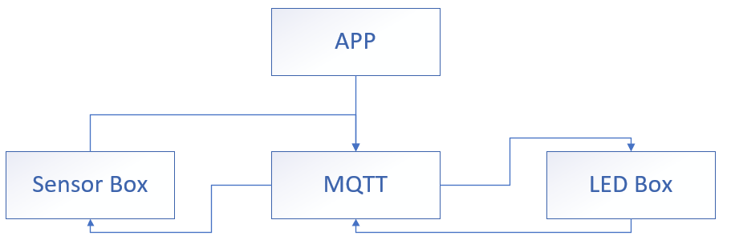

***Figure 3.1 System structure***

As shown

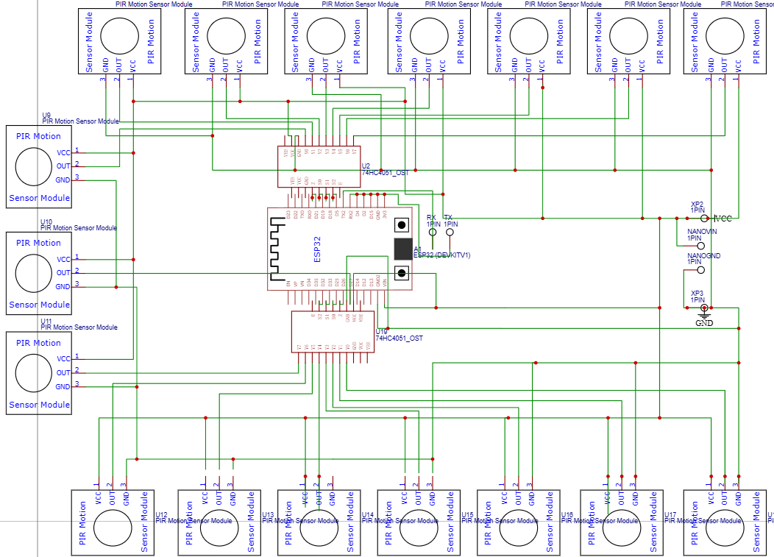 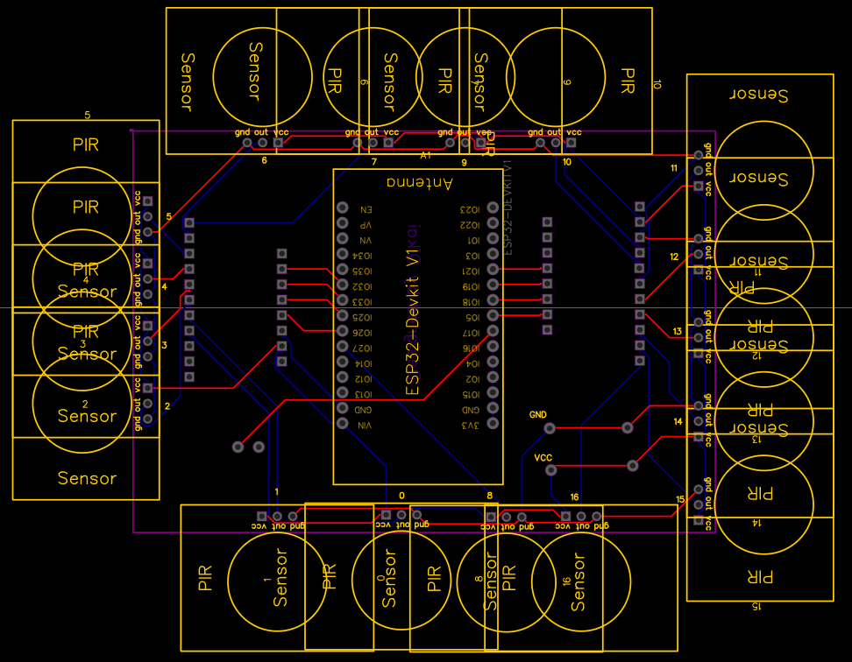

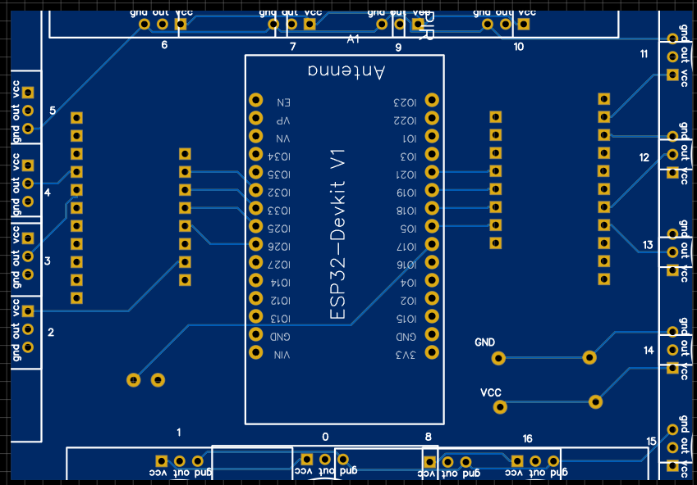

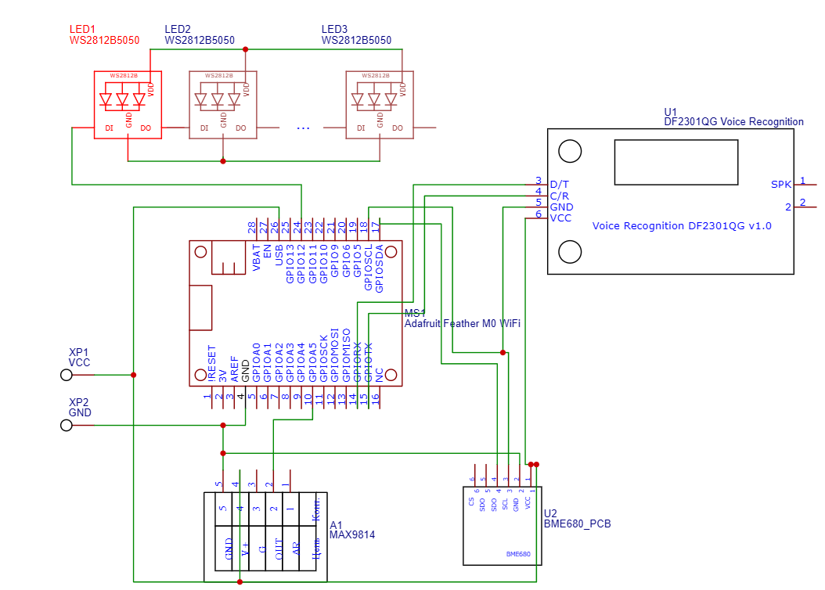

# Reference

1. Byun, J. et al. (2013) ‘Intelligent household LED lighting system considering energy efficiency and user satisfaction’, IEEE Transactions on Consumer Electronics, 59(1), pp. 70–76. doi:10.1109/tce.2013.6490243.
2. Kar, Asim and Kar, Anuradha (2014) ‘Advancements in solid state lighting technology for smart and Energy Efficient Illumination System design’, 2014 International Conference on Green Computing Communication and Electrical Engineering (ICGCCEE) [Preprint]. doi:10.1109/icgccee.2014.6922395.
3. Minker, W. (no date) Next generation intelligent environments: Ambient adaptive systems Tobias Heinroth, Wolfgang Minker, editors. Springer.
4. De Paz, J.F. et al. (2016) ‘Intelligent system for lighting control in Smart Cities’, Information Sciences, 372, pp. 241–255. doi:10.1016/j.ins.2016.08.045.
5. Rashidov, M. et al. (2024) ‘Sound responsive light systems in different signal frequencies for commercial implementation’, 2024 International Conference on Communication, Computer Sciences and Engineering (IC3SE) [Preprint]. doi:10.1109/ic3se62002.2024.10592957.
6. Pauzi, A.F. and Hasan, M.Z. (2020) ‘Development of IOT based weather reporting system’, IOP Conference Series: Materials Science and Engineering, 917(1), p. 012032. doi:10.1088/1757-899x/917/1/012032.
7. Petrariu, A. loan and Coca, E. (2016) ‘Real-time 3D near-field visualization using LED field sensors’, 2016 IEEE 22nd International Symposium for Design and Technology in Electronic Packaging (SIITME) [Preprint]. doi:10.1109/siitme.2016.7777278.
8. Alvarez, J. et al. (2018) ‘A low cost presence detection system for Smart Homes’, 2018 International Conference on Research in Intelligent and Computing in Engineering (RICE) [Preprint]. doi:10.1109/rice.2018.8627901.
9. Tonmoy, A.I., Hossain, M.F. and Hasan, S.Z. (2019a) ‘Voice, gesture and IR remote controlled alphabet learning display for kids based on 16×16 led dot matrix display’, 2019 International Conference on Electrical, Computer and Communication Engineering (ECCE) [Preprint]. doi:10.1109/ecace.2019.8679208.
10. Lin, P. et al. (2019) ‘Design of intelligent voice table lamp controller’, 2019 IEEE 3rd Advanced Information Management, Communicates, Electronic and Automation Control Conference (IMCEC) [Preprint]. doi:10.1109/imcec46724.2019.8984039.
11. Guo, X.Y., Chun Wan, G. and Tong, M.S. (2019) ‘An intelligent control system of music rhythms by RGB-led lamp’, 2019 Photonics &amp; Electromagnetics Research Symposium - Fall (PIERS - Fall) [Preprint]. doi:10.1109/piers-fall48861.2019.9021892.
12. Hovorov, P., Kindinova, A. and Hovorov, V. (2022) ‘Control of the modes of architectural and artistic lighting systems’, 2022 Seventh Junior Conference on Lighting (Lighting) [Preprint]. doi:10.1109/lighting56379.2022.9929010.
13. Rajakumar, P. et al. (2022) ‘Automation of room lighting system using Arduino and Pir Sensor’, 2022 International Conference on Power, Energy, Control and Transmission Systems (ICPECTS) [Preprint]. doi:10.1109/icpects56089.2022.10047213.
14. Hung, C.-H., Bai, Y.-W. and Wu, H.-Y. (2016) ‘Home outlet and LED array lamp controlled by a smartphone with a hand gesture recognition’, 2016 IEEE International Conference on Consumer Electronics (ICCE) [Preprint]. doi:10.1109/icce.2016.7430502.
15. Tian, Y. (2021a) ‘Creative design of a humanized home lighting’, 2021 International Conference on Computer Technology and Media Convergence Design (CTMCD) [Preprint]. doi:10.1109/ctmcd53128.2021.00071.
16. Nguyen-Ly, T.T., Tran, L. and Huynh, T.V. (2019) ‘Low-cost, high-efficiency hardware implementation of smart traffic light system’, 2019 International Symposium on Electrical and Electronics Engineering (ISEE) [Preprint]. doi:10.1109/isee2.2019.8921146.
17. Tsao, Y.-C. et al. (2021) ‘An implementation and design of a digital light switch of smart-home based on MQTT broker’, 2021 IEEE 4th International Conference on Knowledge Innovation and Invention (ICKII) [Preprint].
18. Masykuroh, K. et al. (2021) ‘Prototype smart door lock by using wireless network based on Arduino Uno’, 2021 IEEE International Conference on Communication, Networks and Satellite (COMNETSAT) [Preprint].
19. Jiru, P. (2013) ‘Design of intelligent monitoring system’, 2013 Third International Conference on Instrumentation, Measurement, Computer, Communication and Control [Preprint]. doi:10.1109/imccc.2013.93.
20. Joshitha, C. et al. (2022) ‘Design and implementation of wi-fi enabled contactless electronic stethoscope’, 2022 International Conference on Sustainable Computing and Data Communication Systems (ICSCDS) [Preprint]. doi:10.1109/icscds53736.2022.9760872.
21. Jose, J. and Sasipraba, T. (2019) ‘Indoor air quality monitors using IOT sensors and Lpwan’, 2019 3rd International Conference on Trends in Electronics and Informatics (ICOEI) [Preprint]. doi:10.1109/icoei.2019.8862647.